LAB EXPERIMENT RECORD

SET 18 – PRODUCT INVENTORY MANAGEMENT

Department | AIDS
Course Code / Course Name | DSA0601 / Data Handling and Visualization
Experiment | Data Visualization using R
Name | M.Teja kumar
Register Number | 192424308
Date | 10 October 2026
Day | Saturday

Aim
To analyze product inventory data using a bar chart, stacked-bar visualization, inventory data table, and an interactive Tableau dashboard.

Dataset

Product ID | Product Name | Quantity Available | Price ($)
1 | Product A | 250 | 20
2 | Product B | 175 | 15
3 | Product C | 300 | 18

Data Note
The supplied SET-18 dataset contains Product ID, Product Name, Quantity Available, and Price. It does not contain a separate Product Category field. Therefore, no unsupported product categories are invented in this record. For Program 2, the available product names are used as the grouping variable for the executable visualization.

PROGRAM 1: Bar Chart – Inventory Quantity
To create a bar chart to visualize the quantity of each product in the inventory and label the axes and title.

R Program
# SET 18 - PROGRAM 1
# Product Inventory Quantity Bar Chart

product_id <- c(1, 2, 3)
product_name <- c("Product A", "Product B", "Product C") quantity_available <- c(250, 175, 300)
price <- c(20, 15, 18)

inventory_data <- data.frame( Product_ID = product_id, Product_Name = product_name,
Quantity_Available = quantity_available, Price = price
)
print(inventory_data) barplot(
inventory_data$Quantity_Available, names.arg = inventory_data$Product_Name, main = "Product Inventory Quantity", xlab = "Product",
ylab = "Quantity Available", col = "lightblue",
border = "black"
)

text(
x = seq_along(inventory_data$Quantity_Available), y = inventory_data$Quantity_Available,
labels = inventory_data$Quantity_Available, pos = 3
)

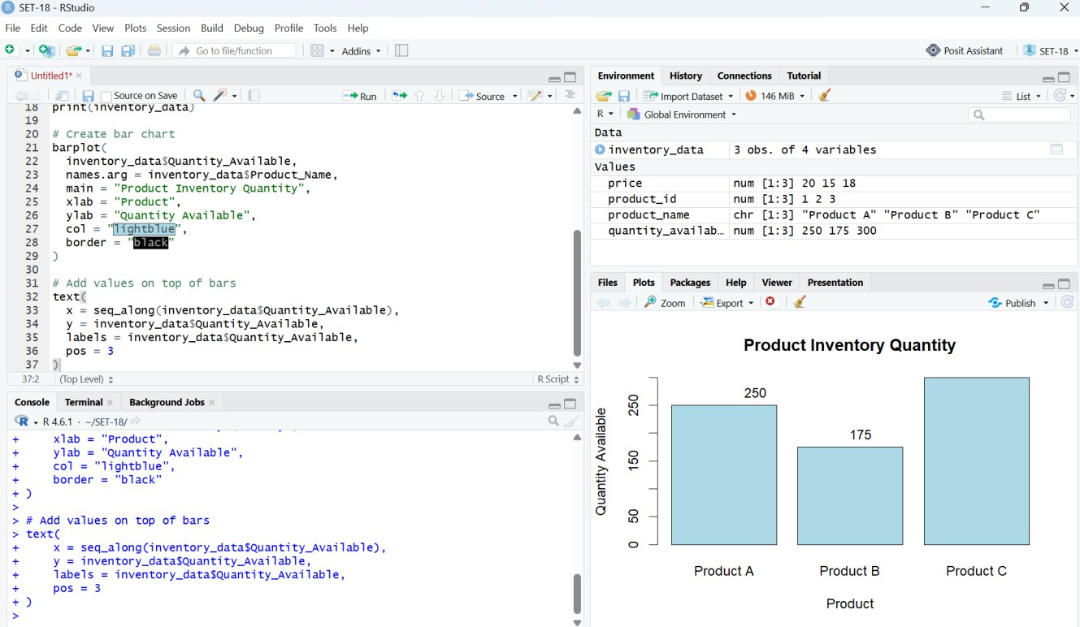

Output 1: Product Inventory Quantity – RStudio Execution Screenshot

Observation: Product C has the highest inventory quantity at 300 units. Product A has 250 units, while Product B has the lowest quantity at 175 units.

PROGRAM 2: Stacked Bar Chart – Product Inventory Distribution
To generate a stacked-bar visualization of inventory quantities. The official question refers to different product categories; however, the supplied dataset does not provide a Product Category column. The following executable version therefore uses Product Name as the available grouping variable.

R Program
# SET 18 - PROGRAM 2
# Product Inventory Distribution

product_name <- c("Product A", "Product B", "Product C") quantity_available <- c(250, 175, 300)

inventory_data <- data.frame( Product_Name = product_name, Quantity_Available = quantity_available
)

quantity_matrix <- matrix( inventory_data$Quantity_Available, nrow = 1
)

colnames(quantity_matrix) <- inventory_data$Product_Name rownames(quantity_matrix) <- "Inventory"

barplot( quantity_matrix,
main = "Product Inventory Distribution", xlab = "Product",
ylab = "Quantity Available",
col = c("lightblue", "lightgreen", "lightpink"), border = "black"
)

legend( "topright",
legend = inventory_data$Product_Name,
fill = c("lightblue", "lightgreen", "lightpink"), title = "Products"
)

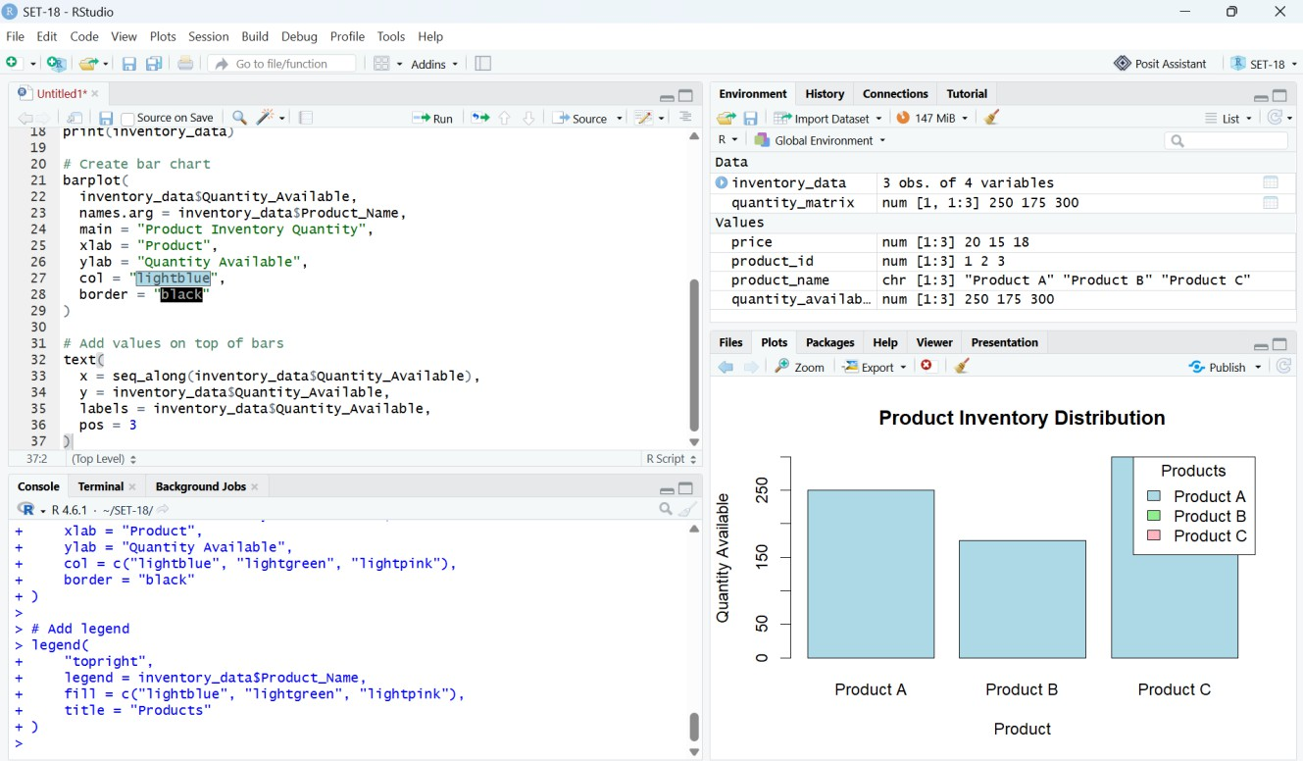

Output 2: Product Inventory Distribution – RStudio Execution Screenshot

Observation: The visualization compares the inventory quantities of the three products. Product C has the largest available quantity, followed by Product A and Product B.
Technical note: The screenshot demonstrates the available-data grouping. A true category-wise stacked bar chart requires a Product Category field, which is absent from the supplied SET-18 dataset.

PROGRAM 3: Inventory Data Table
To build a table displaying the inventory data for each product and label the table elements.

R Program
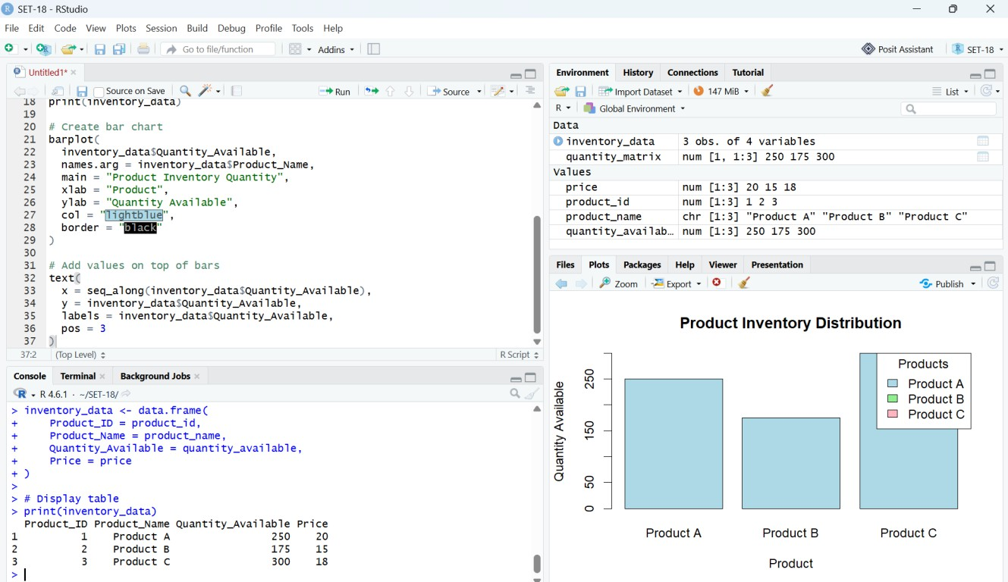
# SET 18 - PROGRAM 3
# Product Inventory Data Table

product_id <- c(1, 2, 3)
product_name <- c("Product A", "Product B", "Product C") quantity_available <- c(250, 175, 300)
price <- c(20, 15, 18)

inventory_data <- data.frame( Product_ID = product_id, Product_Name = product_name,
Quantity_Available = quantity_available, Price = price
)

print(inventory_data)

Output 3: Product Inventory Data – RStudio Execution Screenshot

Observation: The table displays Product ID, Product Name, Quantity Available, and Price for all three products, allowing exact comparison of the inventory records.

Expected Tabular Output

Product ID | Product Name | Quantity Available | Price ($)
1 | Product A | 250 | 20
2 | Product B | 175 | 15
3 | Product C | 300 | 18

PROGRAM 4: Interactive Tableau Dashboard
To develop a Tableau dashboard combining the inventory bar chart, stacked/grouped inventory visualization, and inventory table for interactive exploration of the product inventory data.

Tableau Dashboard Preparation
- Enter the SET-18 inventory data into Excel/CSV and connect the file to Tableau.
- Create Sheet 1: place Product Name on Columns and Quantity Available on Rows to create the inventory bar chart.
- Create Sheet 2: use the available product field for grouping. If a separate Product Category field is supplied later, place Product Category on the category axis and Product Name on Color to create the requested category-wise stacked bar chart.
- Create Sheet 3: add Product ID, Product Name, Quantity Available, and Price to a text table.
- Create a new Dashboard and place the three sheets into the dashboard.
- Add appropriate titles, labels, tooltips, and filters where applicable.
- Verify that selecting or filtering a product updates the displayed inventory information.

Suggested Dashboard Layout

PRODUCT INVENTORY DASHBOARD
Inventory Quantity Bar Chart | Inventory Distribution Stacked / Grouped Chart
Inventory Data Table | Filters / Tooltips  Product-level exploration

Dashboard Interpretation
The dashboard should allow the user to compare available quantities, inspect the complete inventory table, and explore product-level information interactively. Product C should be visually identifiable as the product with the largest inventory quantity.

Procedure
- Create vectors for Product ID, Product Name, Quantity Available, and Price.
- Combine the vectors using data.frame() to create the product inventory dataset.
- Display the inventory dataset using print().
- Create a bar chart using barplot() with Product Name on the x-axis and Quantity Available on the y-axis.
- Add numerical labels above the bars using text().
- Create the inventory distribution visualization using a matrix and barplot().
- Create and print the inventory data table.
- Connect the inventory dataset to Tableau.
- Create the required charts and table as separate Tableau worksheets.
- Combine the worksheets into an interactive Tableau dashboard.
- Verify the displayed values against the supplied SET-18 dataset.

Overall Insights
- Product C has the largest inventory quantity at 300 units.
- Product A has 250 units available.
- Product B has the lowest inventory quantity at 175 units.
- The total inventory across the three products is 725 units.
- Product C therefore contributes the largest share of the available inventory.
- The supplied dataset contains price values of $20, $15, and $18 for Products A, B, and C respectively.
- A category-based stacked chart cannot be faithfully constructed from the supplied data because Product Category is not provided.

Result
The product inventory data was successfully analyzed using RStudio through a bar chart, inventory distribution visualization, and data table. A Tableau dashboard design was specified to combine the visualizations and table for interactive inventory exploration.

Important Submission Note
The RStudio screenshots supplied for SET-18 have been inserted into the corresponding program sections. Program 4 is documented as Tableau dashboard construction steps because no Tableau execution screenshot was supplied. The SET-18 source dataset also lacks Product Category, so the record explicitly identifies this limitation instead of inventing category values.

